Ecosystem Quiz – Study Guide
STEM II – BI 111

Name ________________________

- Define the following terms:

  - Organism

  - Population

  - Community

  - Ecosystem

  - Primary producer

  - Primary consumer

  - Scavenger

  - Food web

  - Food chain

  - Biomass

  - Mutualism

  - Parasitism

  - Commensalism

- List two ways ecologists study the natural world.

- Provide an example of a primary producer.
- Compare the amount of nutrients available in ocean ecosystems to land ecosystems.

- 10% of the energy is available to organisms at the next highest trophic level, how is most of the 90% of energy lost?

- What is another name for a heterotroph?

- Draw what happens during transpiration.
- Provide an example for how biotic and abiotic factors interact.

- List the organization of an ecosystem from simplest to most complex using the following terms: species (organism), ecosystem, communities, populations.

- Algae at the bottom of a food chain can best be described as what trophic level?

- What is the term for each step in the transfer of energy and matter within a food web?

- Describe the role of decomposers in an ecosystem.

- Is transpiration one of the possible steps in the carbon cycle? If not, what cycle is transpiration part of?

- For the diagram, draw arrows to show how energy and matter move through the ecosystem.

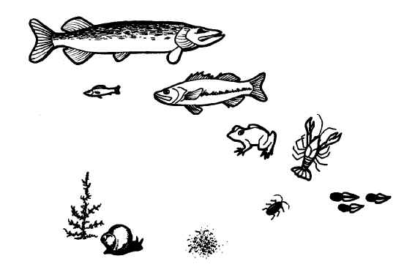
tad poles
plant
detritus

- From the diagram, identify one primary producer ___________________________

- From the diagram, identify one secondary consumer ________________________

- From the diagram, identify one primary consumer __________________________

- From the diagram, identify one tertiary (3rd level) consumer __________________

- From the diagram, identify one decomposer _______________________________

